To create an executable JAR file in Eclipse, follow these steps:

1. Export Project:
   1. Select your project in Eclipse.
   2. Click on the "Export" option.

1. Select Export Wizard:
   1. In the Export wizard, expand the "Java" folder.
   2. Select "Runnable JAR file".
   3. Click "Next".  
      A screenshot of a computer

      Description automatically generated
2. Choose Launch Configuration:
   1. In the "Runnable JAR File Export" window, choose the launch configuration.
   2. Select the appropriate launch configuration from the dropdown menu.  
      A screenshot of a computer

      Description automatically generated
3. Specify JAR File Location:
   1. Specify the location where you want to save the JAR file on your filesystem.
   2. Provide a name for the JAR file.
   3. Click "Finish".
4. Completion:
   1. Once the export process is complete, you should find the executable JAR file in the location you specified.

Steps to Create Self-Signed JAR

1. Open the command prompt and navigate to the 'jdk-8.0.392.8-hotspot\bin' directory.
2. Generate a key pair using the following command:
   1. keytool -genkeypair -keystore banor-bpipe.jks -keyalg RSA -keysize 2048 -validity 3650 -alias banor-bpipe

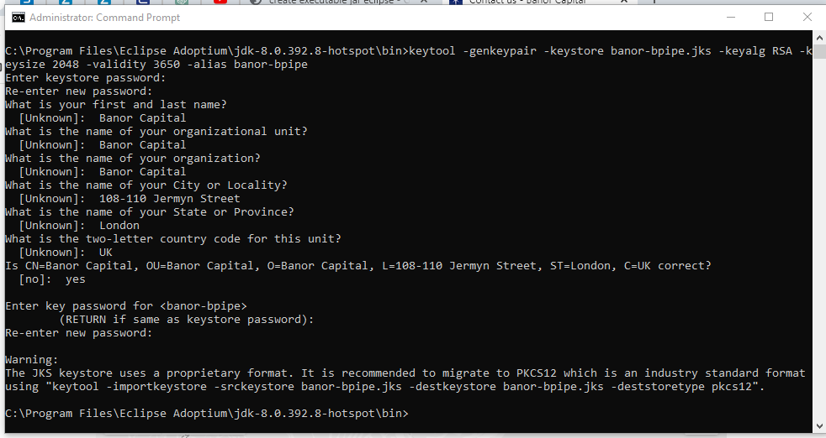

1. List the contents of the keystore to verify the generated key pair:
   1. keytool -list -keystore banor-bpipe.jks -v   
      A screenshot of a computer program

      Description automatically generated
2. Sign the JAR file using the generated key pair and alias 'banor-bpipe':
   1. jarsigner -keystore banor-bpipe.jks -keypass banor123$ -storepass banor123$ D:\Bpipe\Bpipe-banor\banor.jar banor-bpipe   
      A black screen with white text

      Description automatically generated
3. Verify the signature of the signed JAR file:
   1. jarsigner -verify -keystore banor-bpipe.jks -storepass banor123$ D:\Bpipe\Bpipe-banor\banor.jar   
      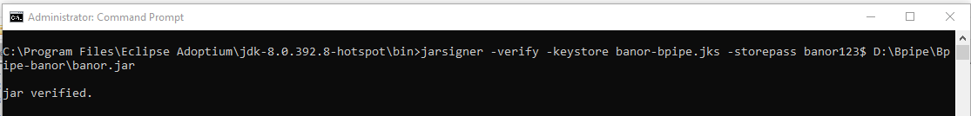

**Note: Ensure to replace 'D:\Bpipe\Bpipe-banor\banor.jar' with the actual path to your JAR file, and 'banor123$' with the appropriate passwords.**

Creating the Executable File using lauch 4j

1. Download Launch4j:
   1. Go to <https://sourceforge.net/projects/launch4j/>
   2. Click on "Download the latest version".
   3. Wait 5 seconds for the download to start.
   4. Open the "launch4j-3.50-win32.exe" in your web browser or Downloads folder.
   5. Click "Yes", then "Next", "I agree".
   6. Optionally, click "Browse" to select an install location.
   7. Click "Install" and then "Finish".
2. Open Launch4j:
   1. Click the Windows Start menu.
   2. Type "Launch4j" and click the Launch4j icon.
3. Select Output File:
   1. Click the blue folder icon next to the "Output file" bar.
   2. Navigate to the desired location to save the file.
   3. Type the desired filename (ensure it has the ".exe" file extension).
   4. Click "Save".
4. Select JAR File:
   1. Click the blue folder icon next to the "Jar" bar.
   2. Navigate to the folder containing your JAR file.
   3. Select the JAR file and click "Open".
5. Select ICO File:
   1. Click the blue folder icon next to the "Ico" bar.
   2. Navigate to the folder containing your ICO file.
   3. Select the ICO file and click "Open".  
      A screenshot of a computer

      Description automatically generated
6. Configure JRE Version:
   1. Click the "JRE" tab.
   2. Type "1.8.0" next to "Min JRE version" or specify another version if needed.
   3. Click the gear button labelled "Build Wrapper".  
      A screenshot of a computer

      Description automatically generated
7. Save XML Configuration:
   1. Specify an appropriate name for the XML (.xml) file.
   2. Click "Save" to create the XML configuration file.  
      A screenshot of a computer

      Description automatically generated

Making Executables (.exe) Installable with Inno Setup

1. Download inno setup:
   1. Go to <https://sourceforge.net/projects/launch4j/>
   2. Click on "inno latest version".
   3. Open the "innosetup-6.2.2.exe" in your web browser or Downloads folder.
   4. Click "Yes", then "Next", "I agree".
   5. Optionally, click "Browse" to select an install location.
   6. Click "Install" and then "Finish".
2. Open inno setup:
   1. Select create a new script file using the Script Wizard  
      A screenshot of a computer program

      Description automatically generated
   2. Fill in the application information  
      A screenshot of a computer

      Description automatically generated
   3. Leave defaults  
      A screenshot of a computer

      Description automatically generated
   4. Select the *.exe file found in the dist folder  
      A screenshot of a computer program

      Description automatically generated  
      A screenshot of a computer program

      Description automatically generated
   5. Select shortcut choices  
      A screenshot of a computer program

      Description automatically generated
   6. Add any license or information files or leave defaults  
      A screenshot of a computer program

      Description automatically generated
   7. Select install mode  
      A screenshot of a computer program

      Description automatically generated
   8. Select the languages  
      A screenshot of a computer program

      Description automatically generated
   9. Provide compiler settings and icon for installable  
      A screenshot of a computer program

      Description automatically generated
   10. Leave default  
       A screenshot of a computer program

       Description automatically generated
   11. Add two lines for adding application in common startup
       1. Name: "{commonstartup}\{#MyAppName}"; Filename: "{app}\{#MyAppExeName}"
   12. Name: "{userprograms}\{groupname}\{#MyAppName}"; Filename: "{app}\{#MyAppExeName}"

* 1. Compile new script
  2. Share around the executable installer!

Installation for banor-bpipe application

1. Click on executable file and start installation.
2. Select Destination location.  
   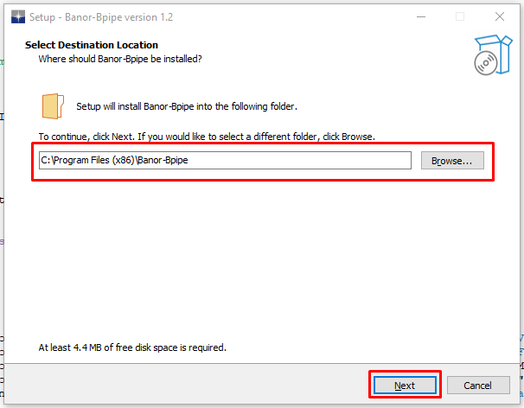
3. Select shortcut options.  
   A screenshot of a computer program

   Description automatically generated
4. Click on install and finish  
   A screenshot of a computer

   Description automatically generated

